Create Opportunity from Lead
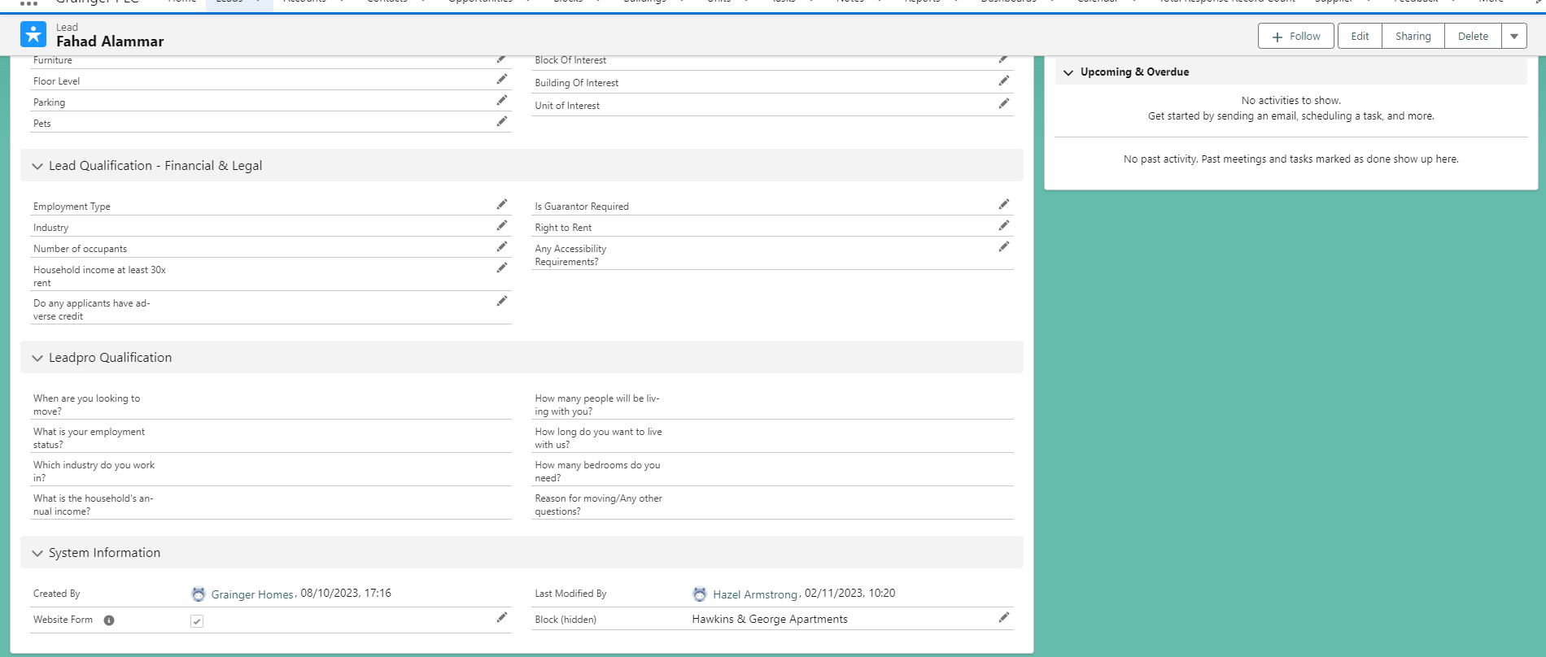
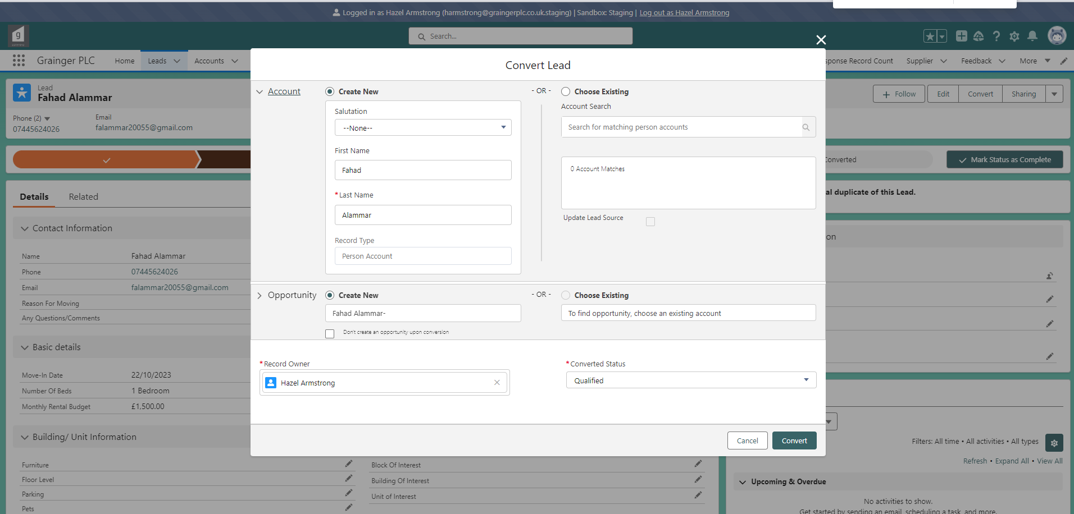

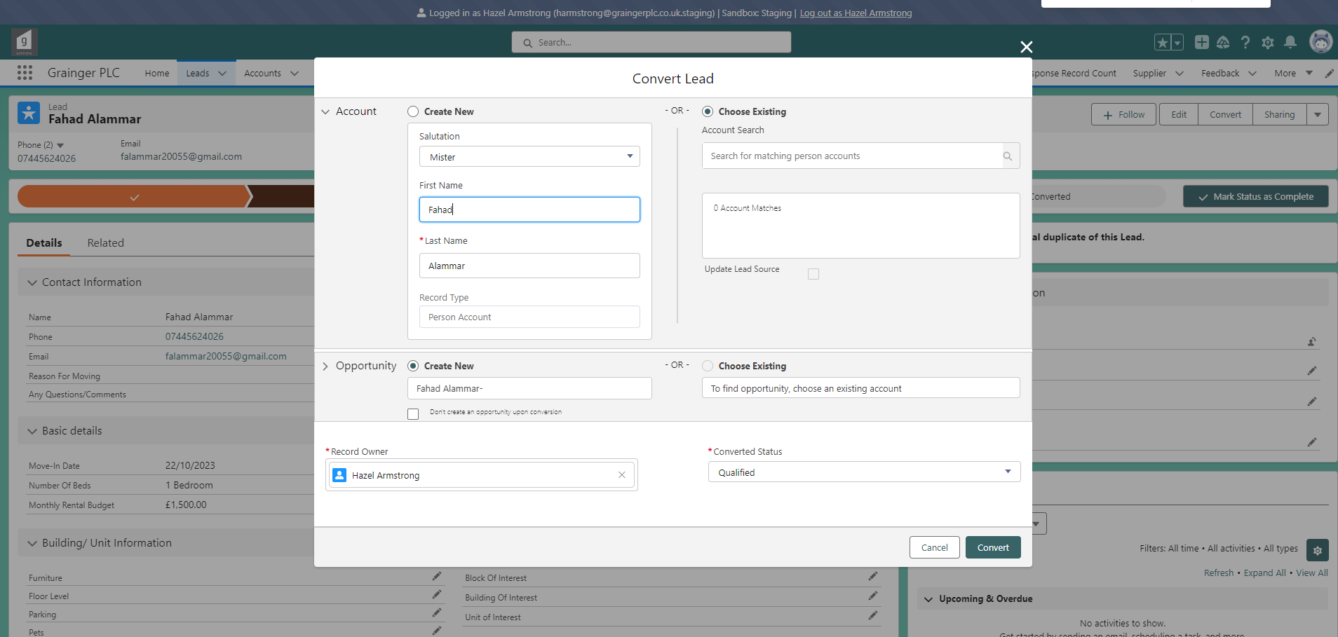
https://graingerplc--staging.sandbox.lightning.force.com/lightning/r/Opportunity/006Ae000008apc9IAA/view
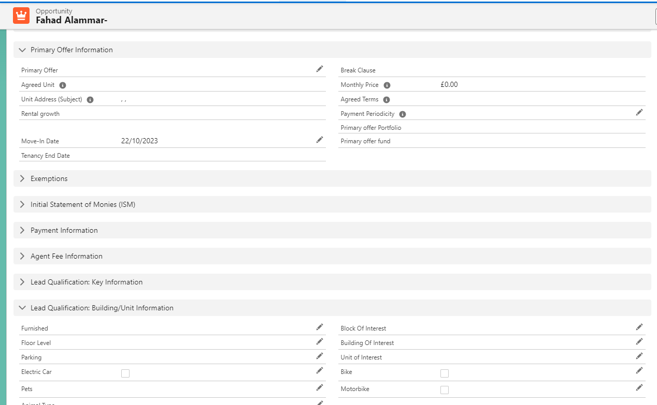

Create New Opportunity
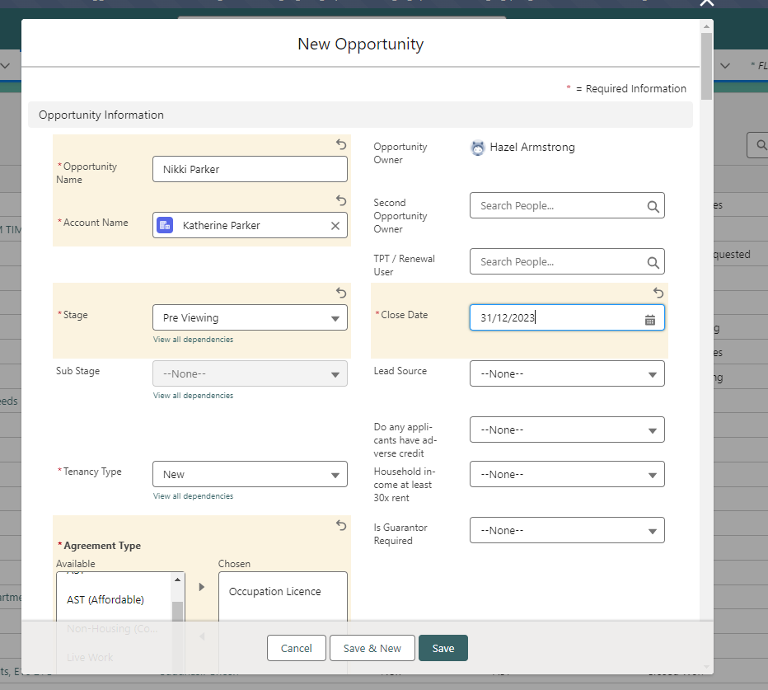

Create new Opportunity
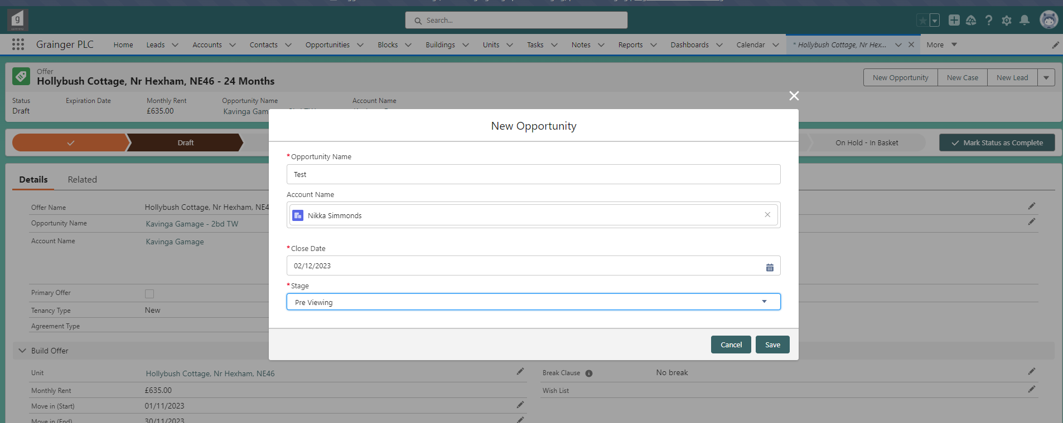
Agreement type is not populated:
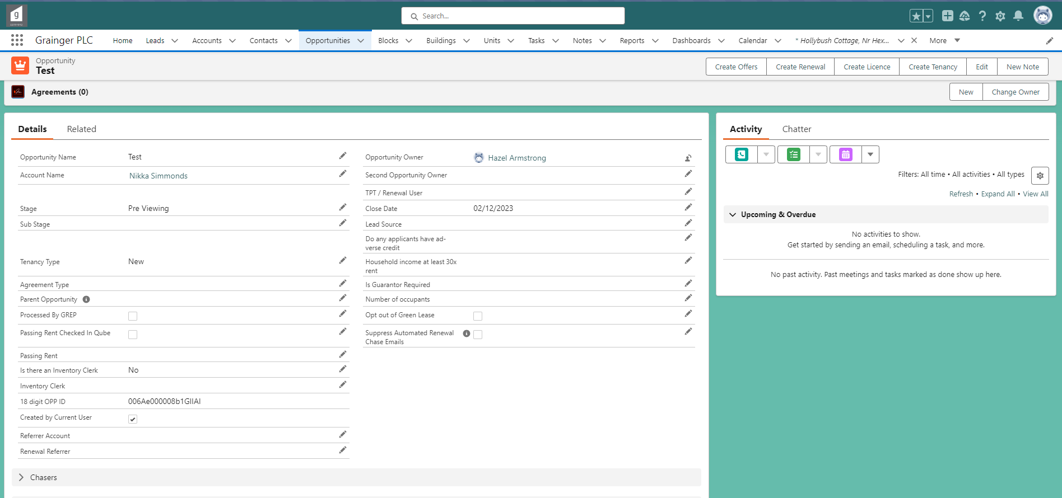

Create Offer
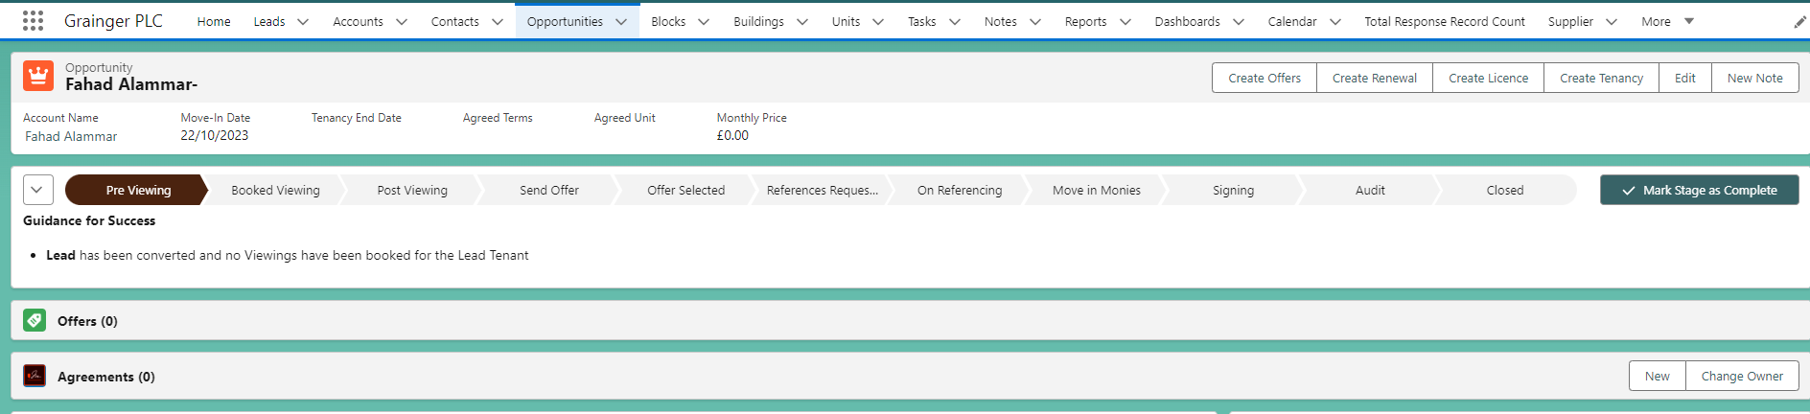
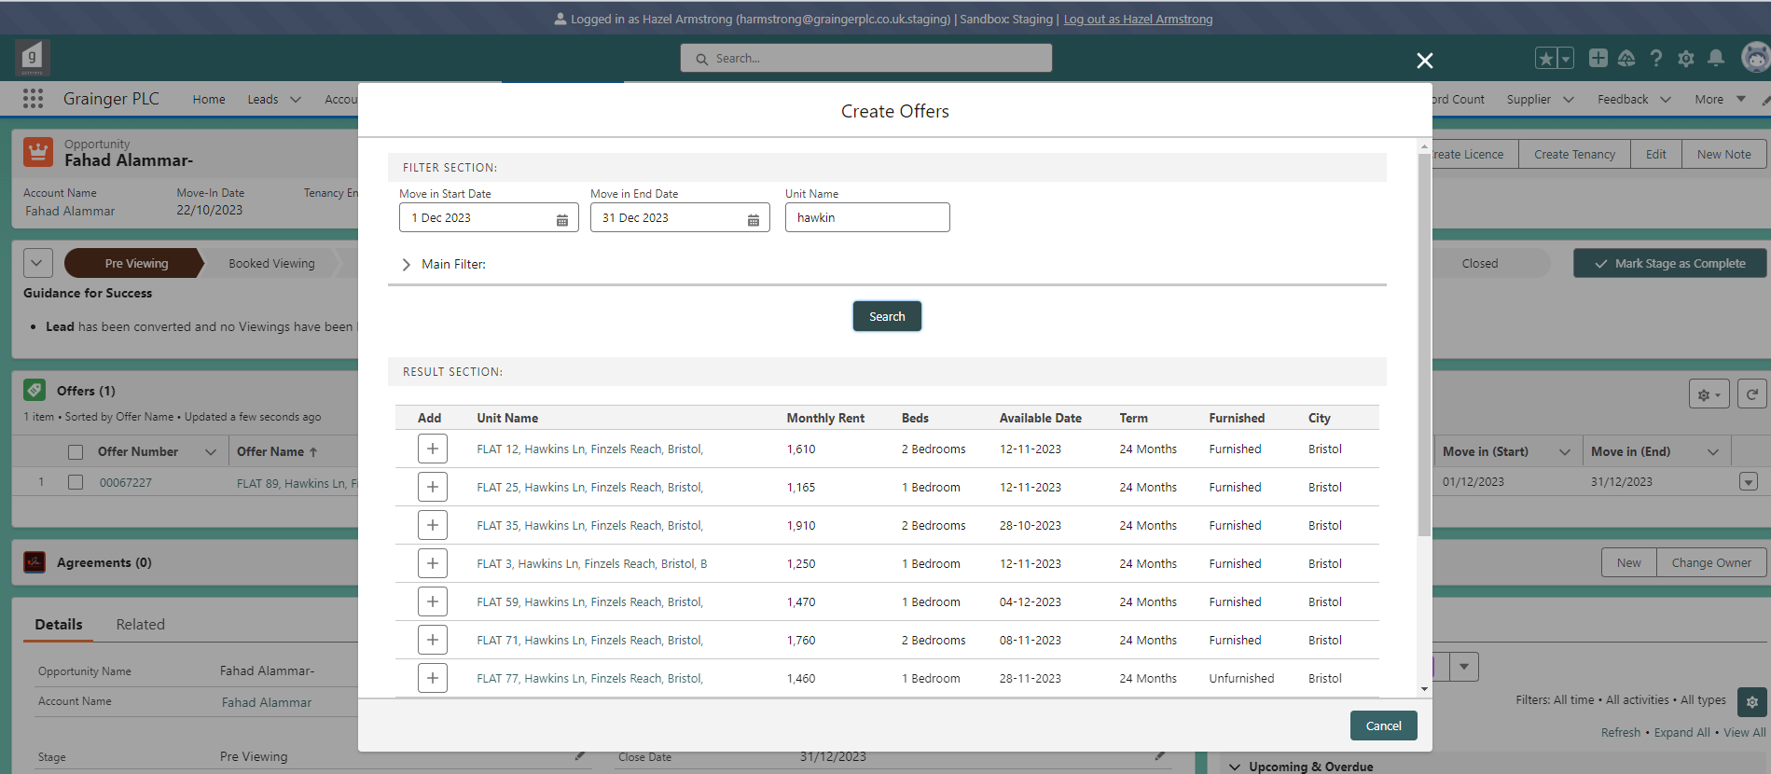
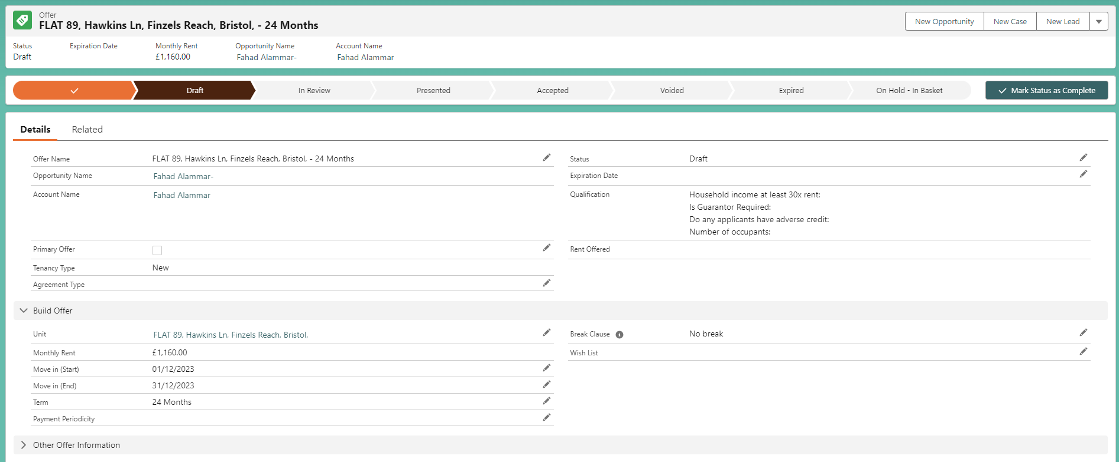

When you flag an offer as the primary, it doesn’t auto save it as the opportunity’s primary offer.
When you save the opportunity’s primary offer, then it auto saves as the opportunity’s

